### **Donfred Vallon**

### **W03 Project: Rafting Site – Planning Document**

#### **1. Logo Selection**

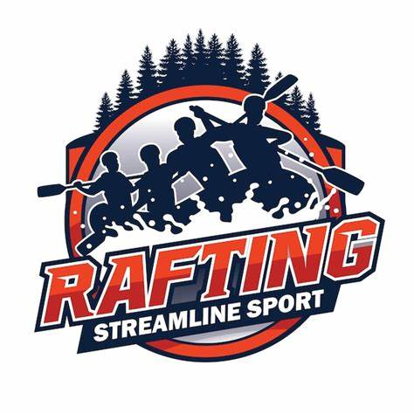

*Image Source:* [*Freepik - Rafting Logo Design*](https://www.freepik.com/premium-vector/rafting-logo-design-river-white-water-rafting-logo_38125426.htm)[Freepik](https://www.freepik.com/premium-vector/rafting-logo-design-river-white-water-rafting-logo_38125426.htm?utm_source=chatgpt.com)

#### **2. Color Palette**

Using [Coolors.co](https://coolors.co/), the following color palette has been selected for the rafting website:

* **Primary Color**: #1D3557
* **Secondary Color**: #457B9D
* **Accent1 Color**: #A8DADC
* **Accent2 Color**: #F1FAEE

*Color Palette URL*: <https://coolors.co/1d3557-457b9d-a8dadc-f1faee>

#### **3. Typography**

Selected fonts from [Google Fonts](https://fonts.google.com/) for the website:

* **Heading Font**: [Oswald](https://fonts.google.com/specimen/Oswald)
* **Text Font**: [Open Sans](https://fonts.google.com/specimen/Open+Sans)

**4. Summary**

This planning document outlines the foundational elements for the Whitewater Rafting website project, including the selected logo, color scheme, and typography choices. These elements are chosen to reflect the adventurous spirit and professionalism of the rafting company, ensuring a cohesive and engaging user experience.